# **Project part**

## sYSTEM SETUP

I tried to create server1 in virtual machine, but it always required to put login and password to launch the server1.

### Configure host name

To configure the host name, I used the hostnamectl to configure it. I used the hostnamectl command to save the changes because if I used the hostname command without ctl, it would change the hostname, but if I restarted the terminal again, it would not save the new hostname. I configured the hostname to server1.tshoot.com as shown in the figure below.



I closed the terminal and ran it again to check if the hostname saved, I run (hostname) command to see if the change I made saved or not. As shown in the figure below, the output was server1 which is what I wanted.

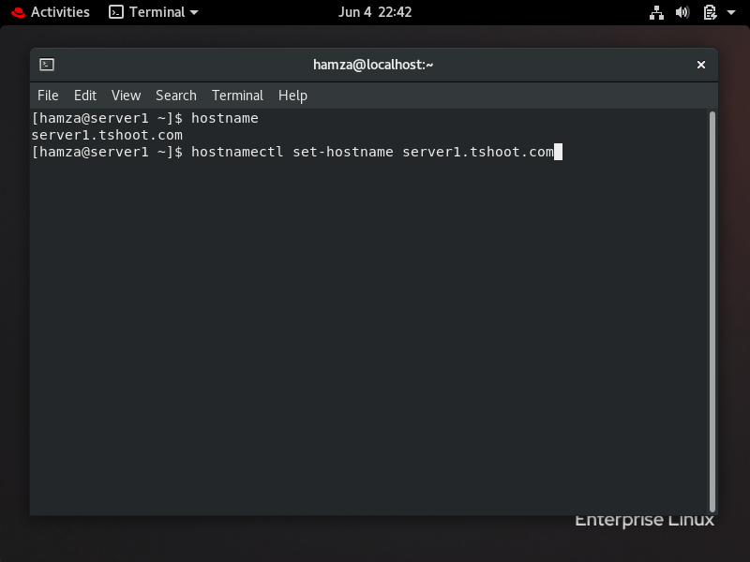

Then, I entered the (/etc/hosts) file to show the hosts in the system, I added the hostname (server1) to the file as shown in the two figures below.

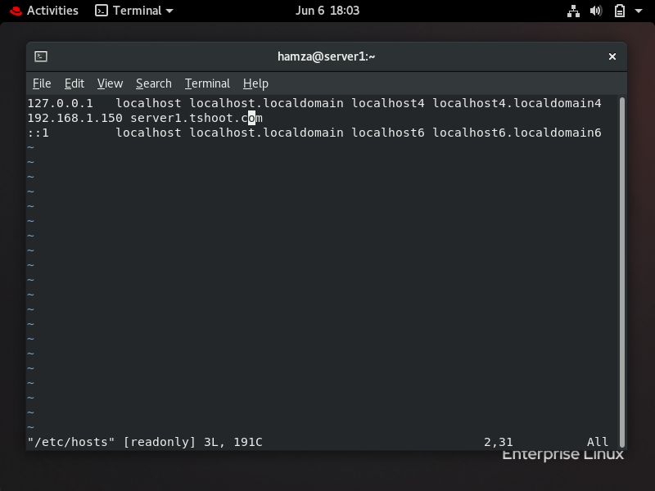

### Configure ip address, DNS, AND gATEWAY

Before I configured the network settings of server1, I wanted to display the interface name by using the command ifconfig as shown in the figure below.

My interface was (enp0s3) and the IP address: 10.0.2.15 , I want to configure the IP address, DNS and gateway by using nmcli command as shown in the figure below. First, I entered the root to configure, I used (su) command to access the root account.

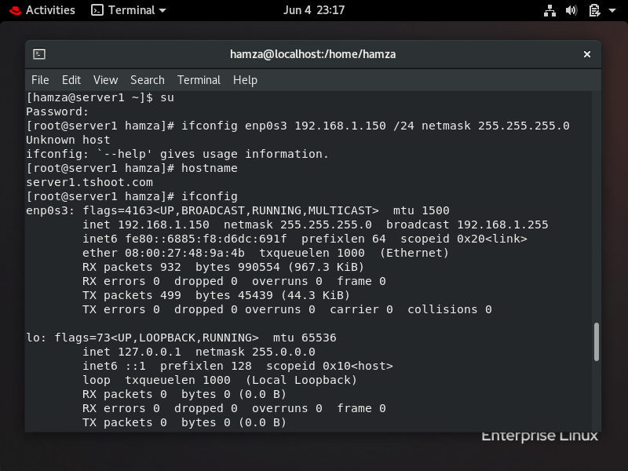

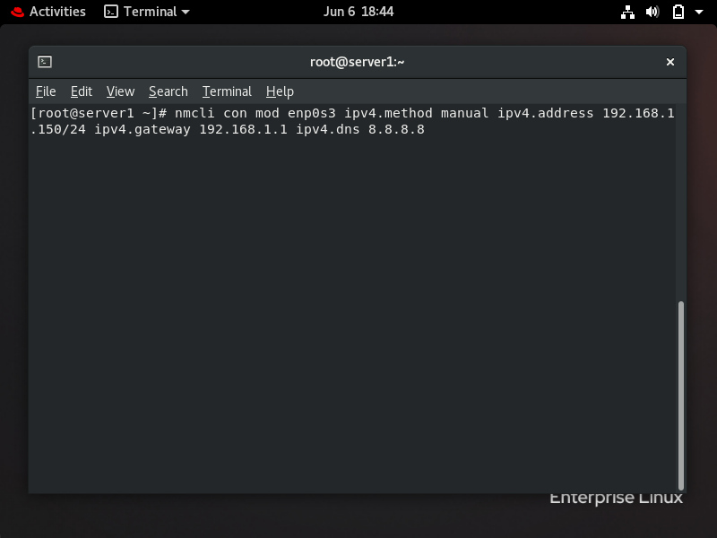

By using nmcli command with connection modify (method manual), IP address, DNS and gateway were configured as required. To test if the IP address, DNS and gateway were configured, I used nmcli connection show with my interface name. I used grep to show only the IP address, Gateway and DNS as shown in the figure below.

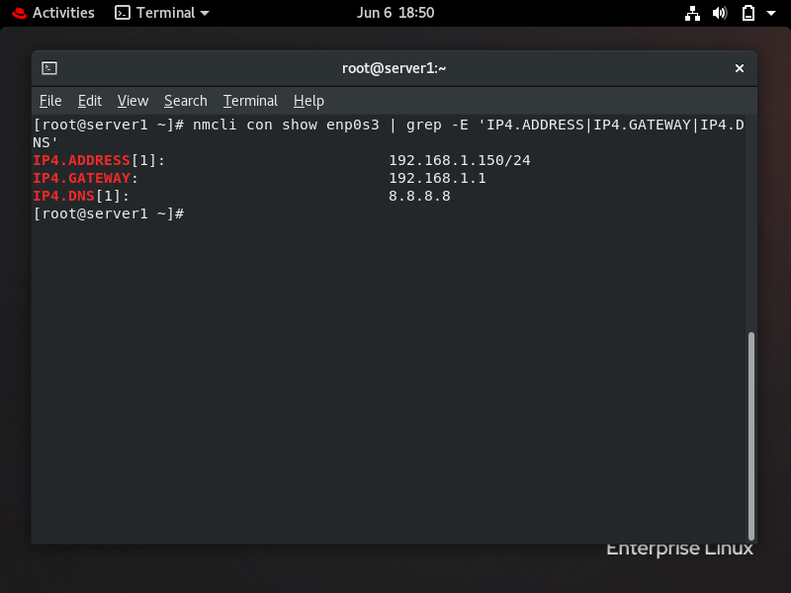

### Cofigure password for root

I used (passwd) command to configure the root password, I changed the password to HTU@2023 as shown in the figure below.

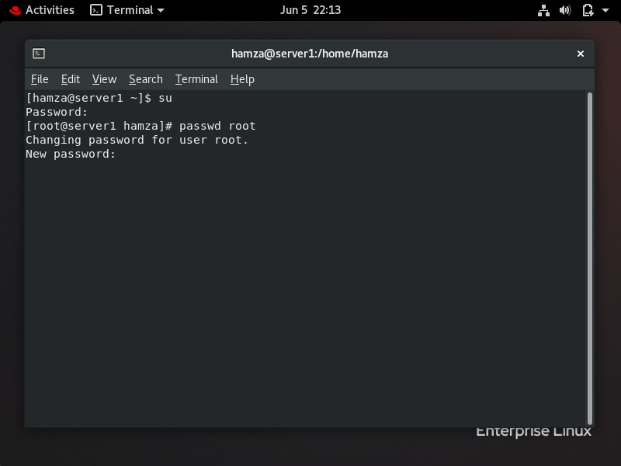

After that I used command (reboot) to restart the machine and check if the password changed or not. It correctly changed.

## Configure the system to my time zone and configure ntp

TO set my time zone, I used timedatectl with set-timezone command to set my time zone (Asia/Amman), I also used the same command but with set-ntp-true to configure the ntp. After that, I checked the time and ntp sync by using timedatectl command as shown in the figure below. The outputs are also shown in the figure.

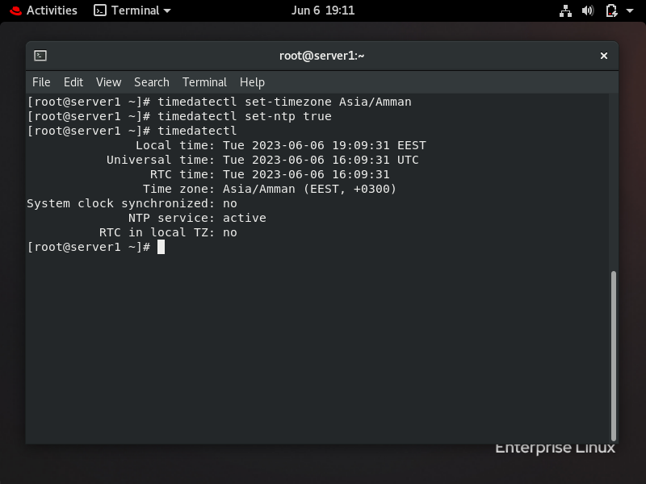

## Repositories

To put repositories in the system, first, I accessed the /yum.repos.d/ file that contains the repositories. After that, I used vim command and (name.repo)to create a file for the first repository I named the file for first repo (basesos.repo), as shown in the figure below.

After, when I ran the command (vim baseos.repo), It opened the file as shown in the figure below. In the file, I put the information showed in the figure below (name, url,enable and gpgcheck) for the first repository. After I put the information in, I saved changes and exited the file by pressing (:wq).

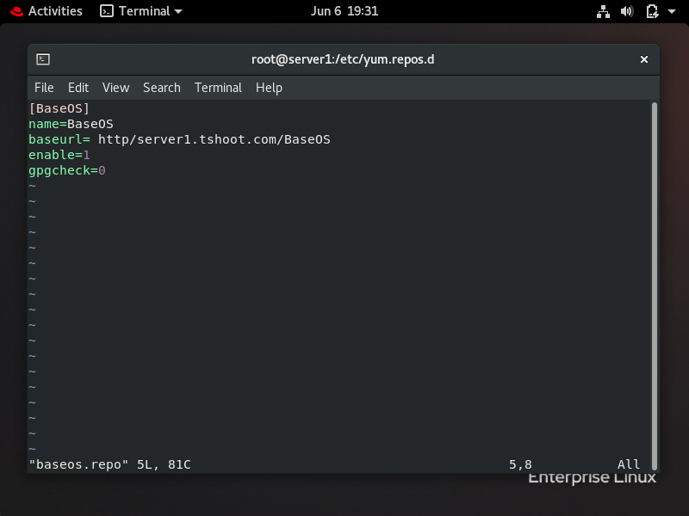

I did the same thing with the second repo, I used vim with the name file as shown in the figure below. The file name of second repo is (appstream.repo).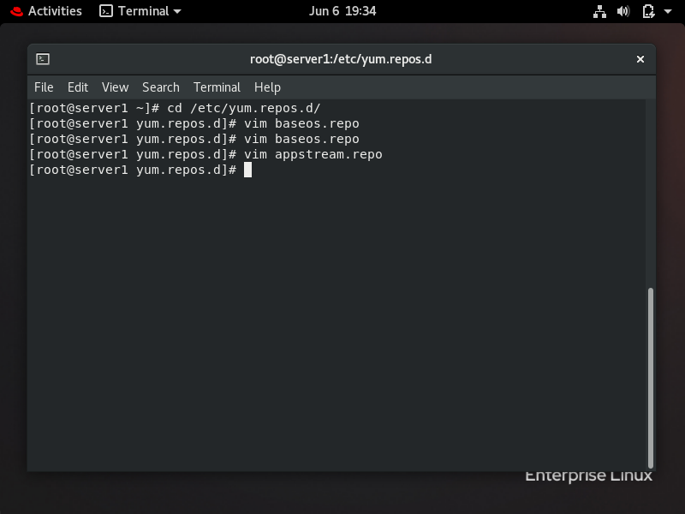

After, when I ran the command (vim appstream.repo), It opened the file as shown in the figure below. In the file, I put the information showed in the figure below (name, url,enable and gpgcheck) for the second repository. After I put the information in, I saved changes and exited the file by pressing (:wq).

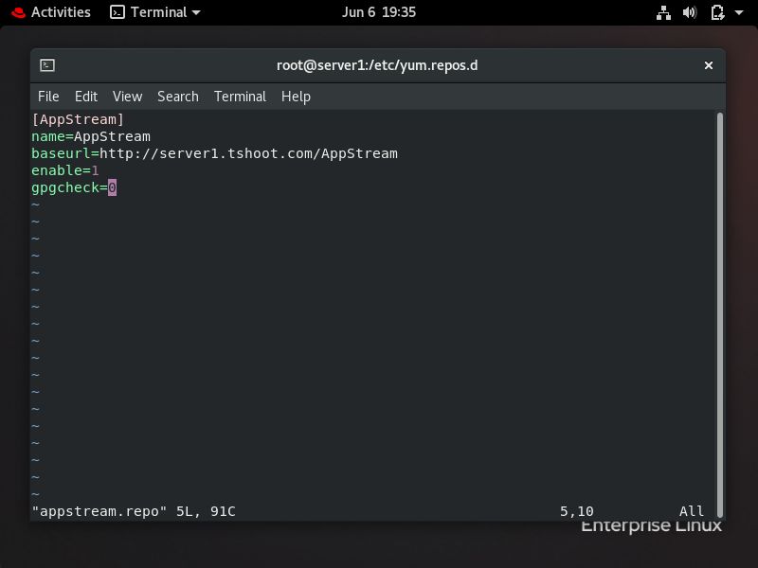

I tested the repositories I made by using (yum repolist), as shown in the figure below, it showed the repositories name that I made (AppStream and BaseOS).

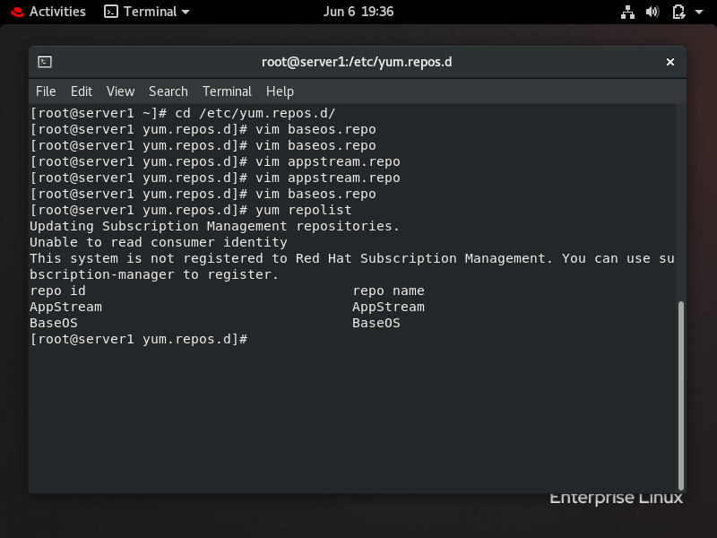

## Firewall

I used systemctl with is-enabled (firewalld) to check if the firewall configured or not, the output was enabled which means that the firewall configured in the system and worked at boot. To ensure more, I also used systemctl with is-active to check if the firewall is active and running, the output was activ e which means that the firwall is enabled and acitve in the system as shown in the figure below.

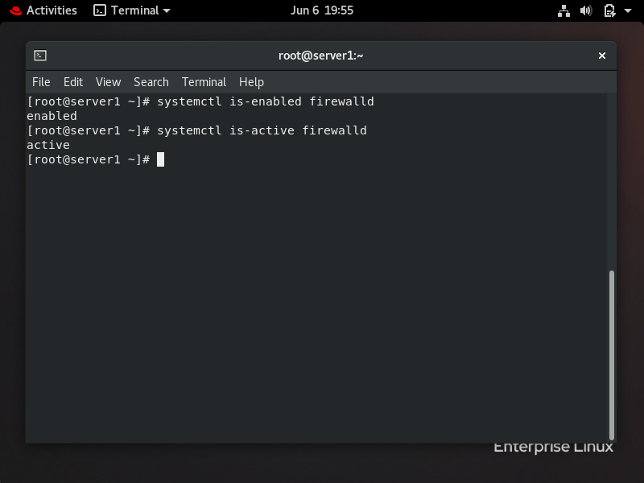

After I ensured that the firewall is active, I used firewall-cmd with list services to show the services related to the firewall as shown in the figure below. The output of the services are also shown in the figure below.

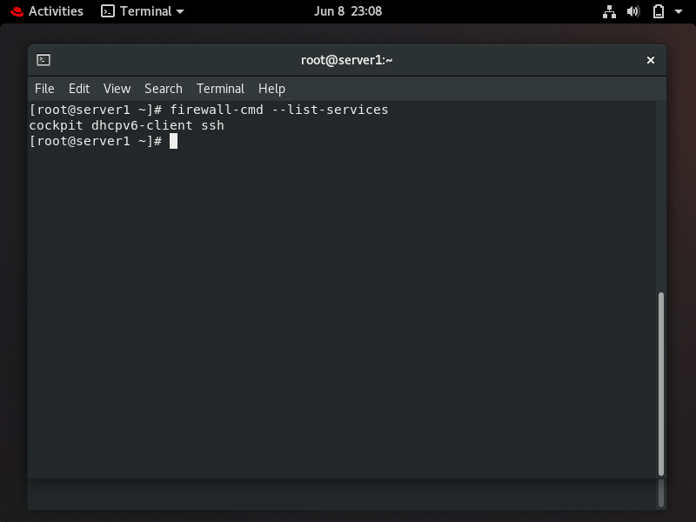

## Check netowrk settings

To check network settings from a regular user, I exited from the root user by using (exit) command. After that, I used many ways to check the settings , first one was by using (ip addr) command to show information about the interface such as IP address, subnet mask, ipv6 and others. As shown in the figure below, the output showed that the IP address 192.168.1.150 is what we want. Also I used nmcli connection show with interface name and grep to show the IP address , DNS and gateway as shown in the figure below.

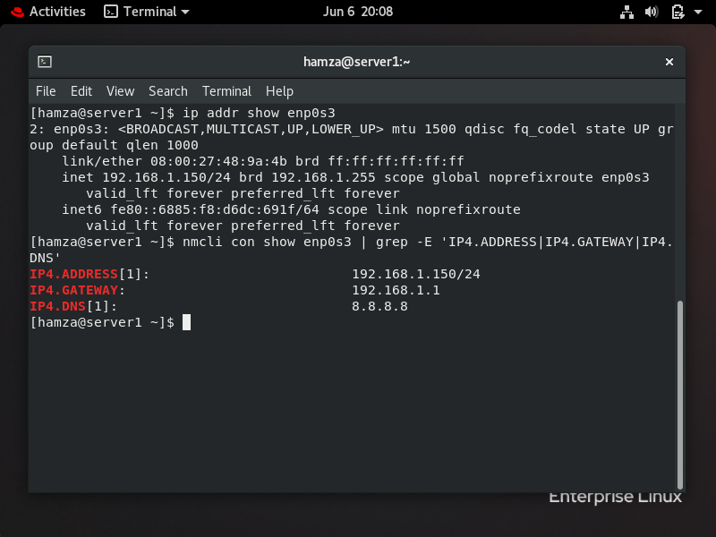

I also accessed the (/etc/resolv.cong) which contains information about DNS. I accessed the file using (cat) command as shown in the figure below. I also used (ip route) command to gateway as shown in the figure below. From the figure below, the gateway is the first (192.168.1.1) which is what we wanted.

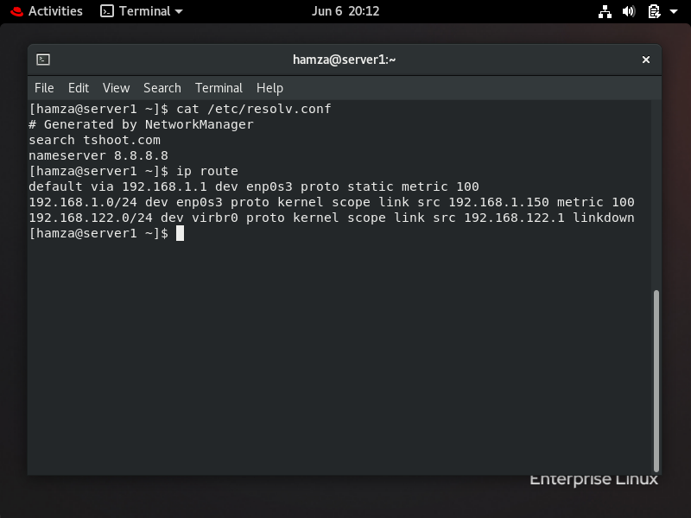

## Secondry ipv4 and ipv6

To set a secondary IPV4, I used the same command as to set the IPV4 before which is by using nmcli with connection modify, but the difference is to add (+) which means secondary IP address as shown in the figure below. I used nmcli with connection show to checked if the secondary IP address didn’t affect the first IP address and compromised my existing settings.

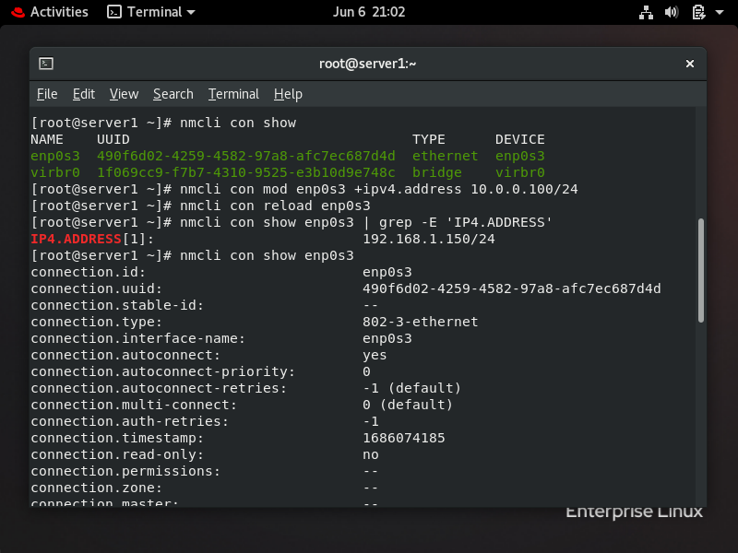

As show in the figure below, the secondray IP address didn’t affect the first IP address and my existing settings.

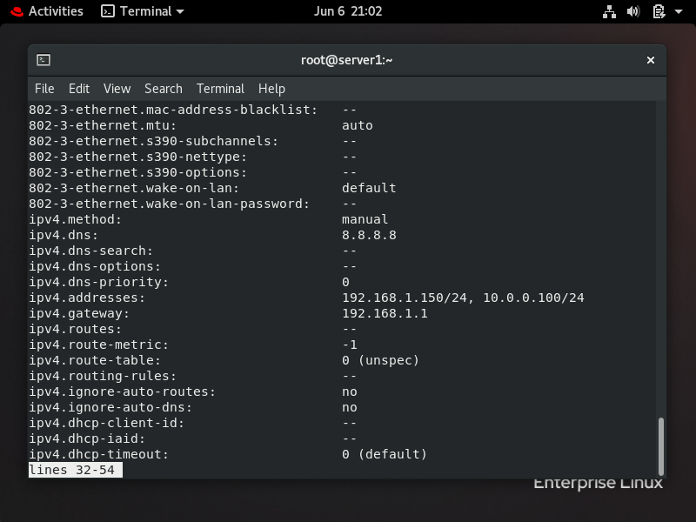



To set a secondary IPV6, I used the same command as to set the secondary IPV4 which is by using nmcli with connection modify, but the difference is to change the number from 4 to 6 and add the ipv6 address as shown in the figure below. I also used nmcli with connection show to checked if the secondary IP address didn’t compromise my existing settings.

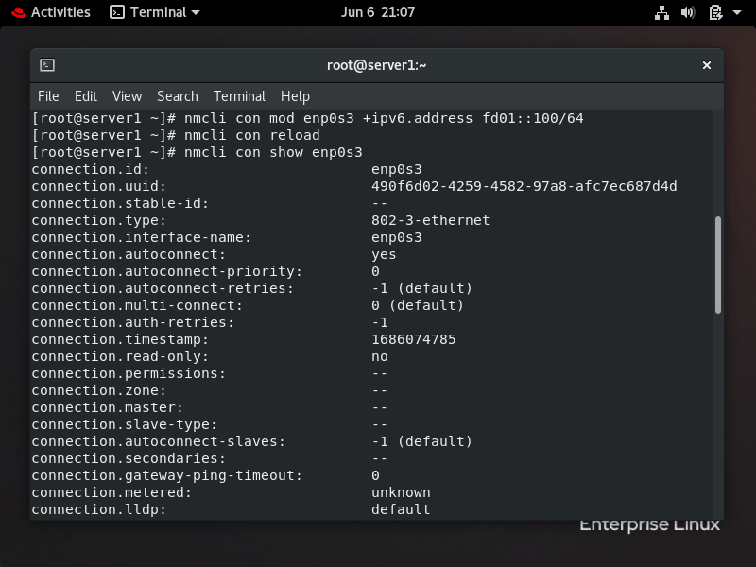

As show in the figure below, the secondray IP address didn’t affect the first IP address and my existing settings.

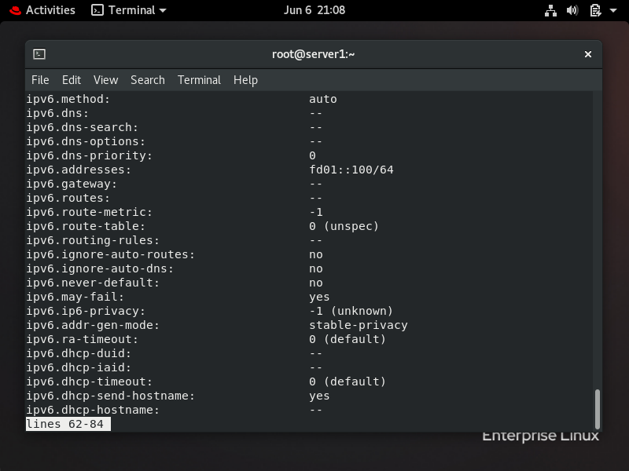

## Explore built in help features

I used (man) command to research the fstab file, and the output of the file is shown in the figure below. Man pages is one of the important commands that helps different forms of documents should be classified and categorized. For example, of man sections, there is section 3 showed the commands and programs that the users can do, section 5 is showing the file format and conventions and section 8 shows the system administration commands or daemons.

The sections that I mentioned before is the most important section for the admins because these sections provide admins important information such as commands, conventions, file format and other information.

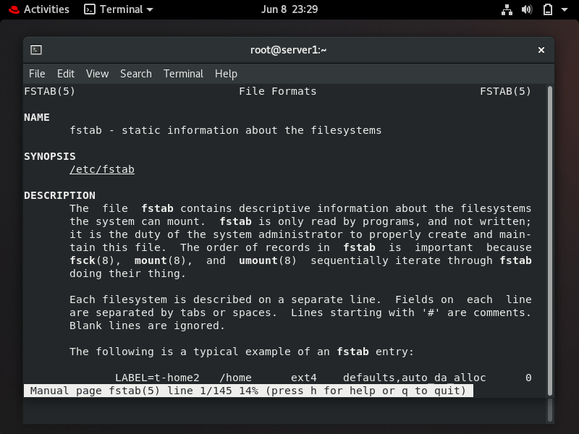

### Turn off the use of colors in of the ls command

I turned off the colors of the ls command by using the option (color= never) as shown in the figure below, and then I redirected the output to the file called (/home/student/lscolor.txt) by using operation “>” which means redirect the output to specific file.



## Head and tail

As shown in the figure below, I first make a directory called student in home by using mkdir command. Then I displayed the first 5 lines of etc/sudoers file by using head command with (n 5) option that means that show first 5 lines. And then I redirected the output of head command to a file called (headtail.txt) in student directory using operation “>” which means redirect the output to specific file. To ensure that the output is redirected to specific file, I used cat command to show the content of file headtail.txt as shown in the figure below.

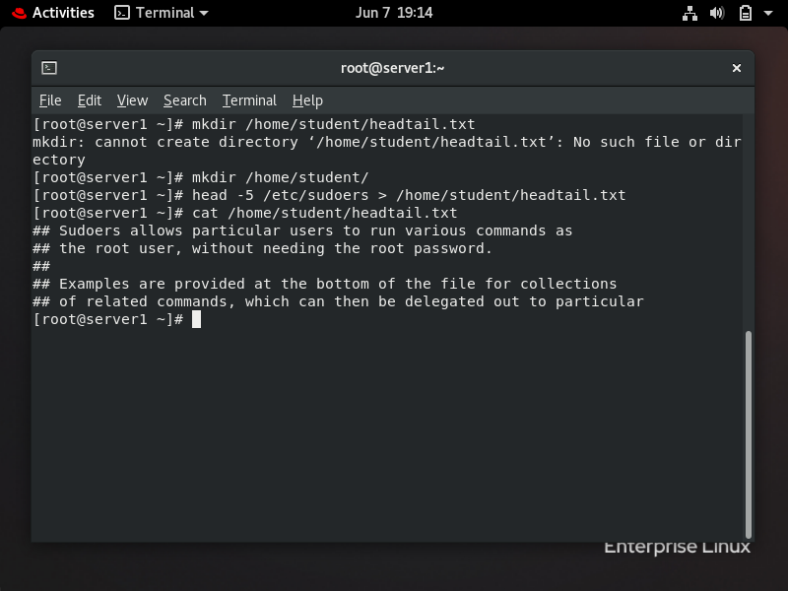

Also, as shown in the figure below, I displayed the last 9 lines of etc/sudoers file by using tail command with (n -9) option that means that show the last 9 lines of a specific file or directory. And then I appended the output of tail command to a file called (headtail.txt) in student directory using operation “>>” which means appended the output to specific file without changing the content of the file. To ensure that the output is redirected to specific file, I used cat command to show the content of file headtail.txt as shown in the figure below. The file (headtail.txt) will show the first 5 lines (from head command) and last 9 lines (from tail command) of file sudoers.

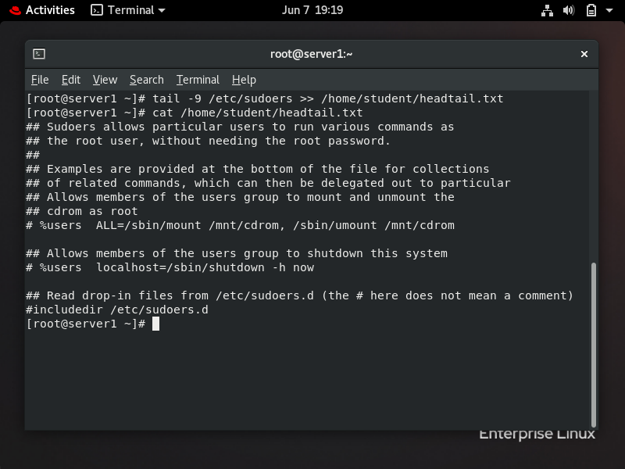

## Create directories

I created directories by using the “mkdir” command. As shown in the figure below , I created five directories using the mkdir command. Then, I checked if the file successfully created, I used “ls” with option “/” to see all the directories created in the system as shown in the figure below.

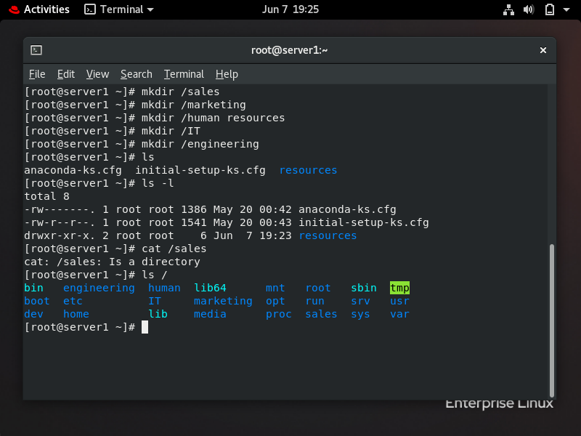

## Configure permissions

After I created the directories, I sat some permissions for these directories by using chmod command with numerical method to set permissions, I set 770 which means first 7 for owner (read, write and execute), second 7 for the group (read write and execution) and 0 for others that are not related to the group and owner (no read, write , and execution). I made the same permission (770) to all the five directories in the system as show in the figure below.

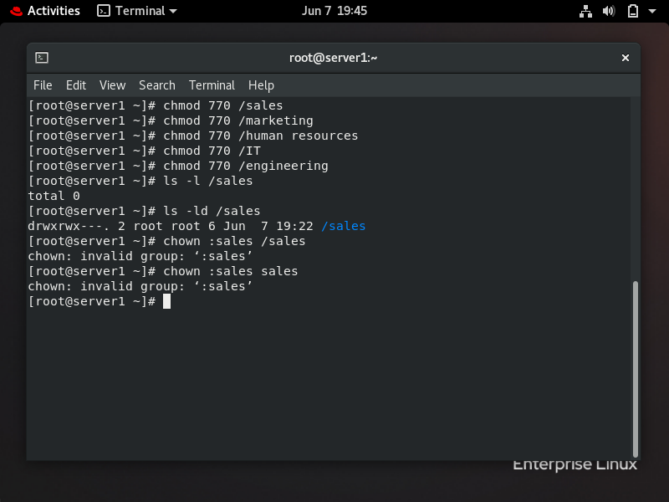

I also created five groups by using groupadd command to create five groups named (sales, marketing, humanresources, IT and enginerring), then I changed the group owner of each of the directories before from root to these groups by using chown command as shown in the figure below so that each group only has access to its own departmental directories.

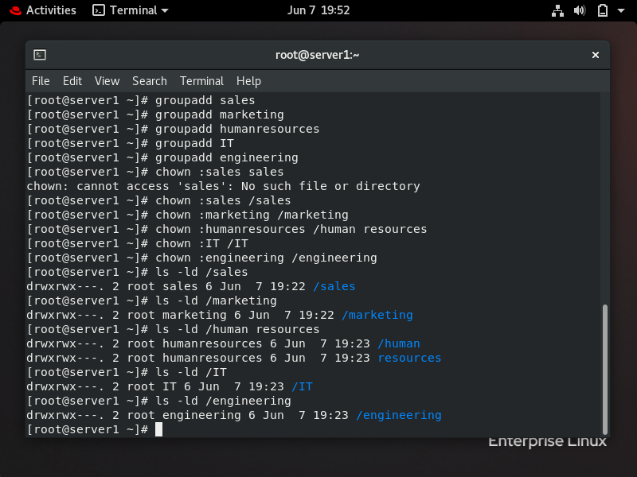

### Sticky bit

I configured sticky bit on the sales directory which means that only the owner and root of the file can delete files within the directory. I configured sticky bit by using the chmod command with option o+t which means sticky bit as show in the figure below. I checked the permission of sales directory by using “ls” with option -ld (for directory), the output is shown in the figure below.

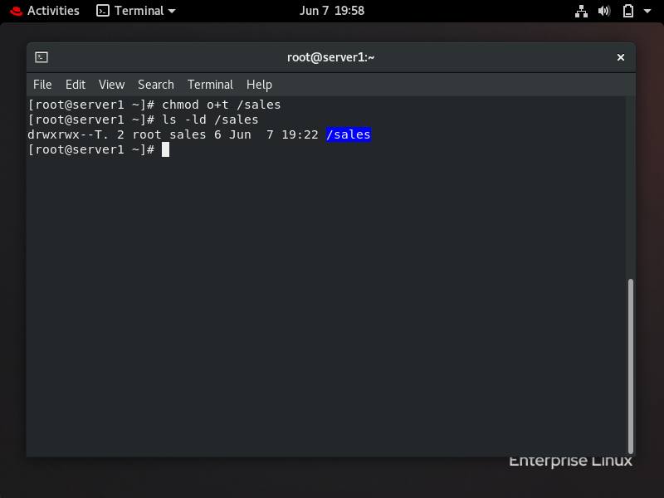

### Create files, set group id and permissions

To create files in sales directory , I first entered the sales directory by using cd command , and then I created three files called (test1,test2,and test3) using touch command as shown in the figure below.

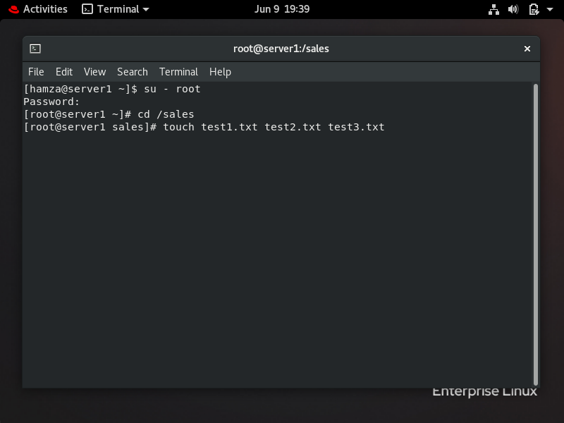To ensure that the files are created, I used ls command as shown in the figure below.

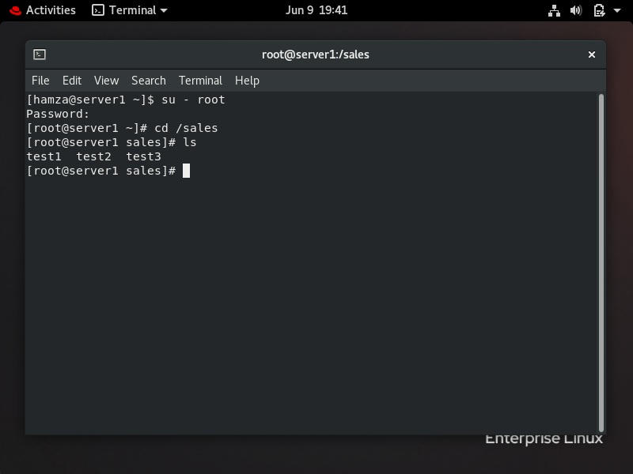

I made the sales directory as a shared folder by using one of the special permissions which is group set id (g+s). I configured the directory using chmod command with option (g+s) as shown in the figure below. I checked the permissions by using “ls” with option “ld” as shown in the figure below. After that I made IT directory and the sales directory read only for the owner and the group by using chmod command with permission (440) for both sales and IT as shown in the figure. 440 -> first four for owner (read only) , second four for group (read only) and last 0 for others (no read, write , and execute) as shown in the figure below.

## Create users

I created four user accounts in the system by using useradd command and then assigned password for each of the users by using passwd command as shown in the figure below.

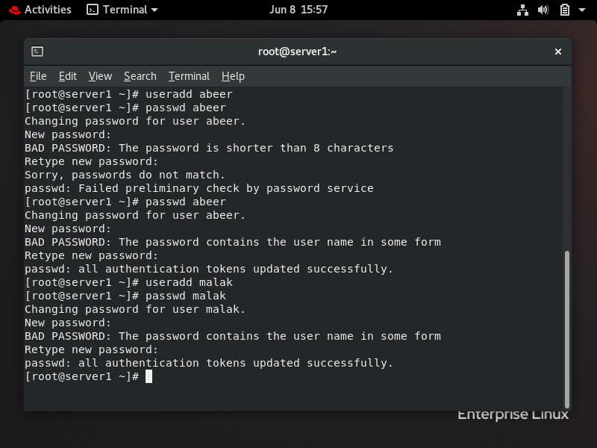

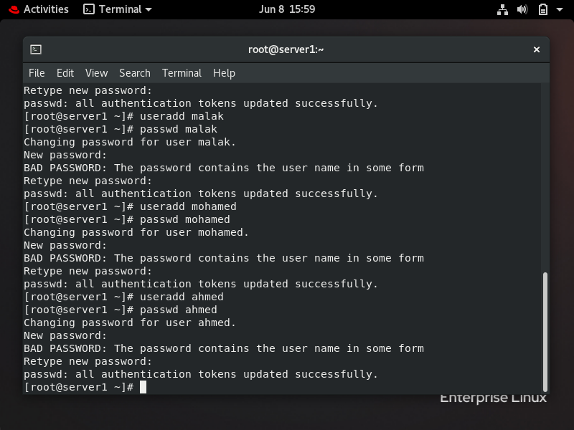

I also made all the users passwords expire after 60 days by using command passwd with option -x which means expire password as shown in the figure below. I also sat expire warning message before 3 days by using chage command with option -W as shown in the figure. The options I selected to use by using (--help).

I put Abeer and Malak accounts in the sales group by using usermod command with option -G which means to set the user account in the group without effecting the other groups that user account joined previously. I also did the same thing with users Mohamed and Ahmed but I put them in IT directory y using the same command and option as shown in the figure below.

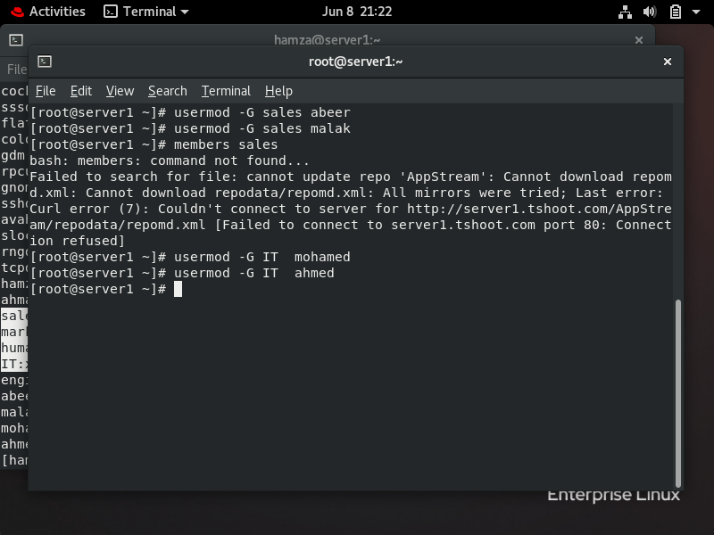

I also made Abeer account the owner of human resources directory by using chown as shown in the figure below. I checked if Abeer became the owner by using “ls” command with option “ld” as shown in the figure below. I restricted access to the human resources directory to only members of the group by using chmod chommand with permission (770) to human resources directory as shown in the figure below.

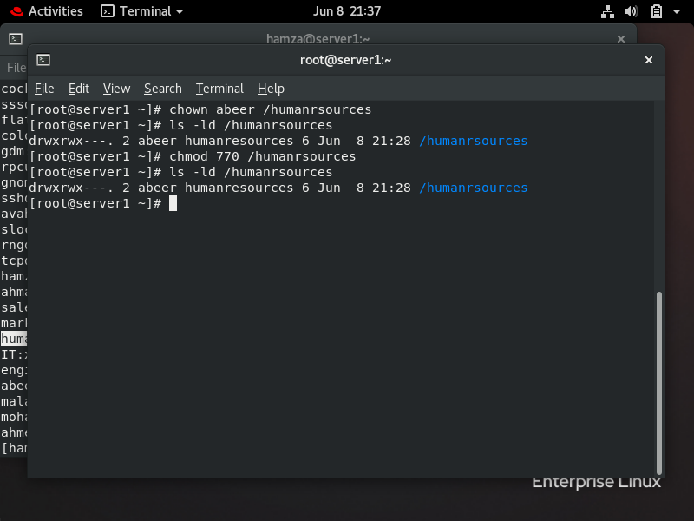

## Change abeer’s password

From Malak user, I changed the password of the Abeer user, firstly, I changed to Malak user by using “su” command to change users, after that, I used “sudo” command (to take administrative privileges) with passwd command to change Abeer password as shown in the figure below. Check: I exited from Malak user and accessed another regular user and tried to entered the Abeer user with the new password, the new password was correctly configured.

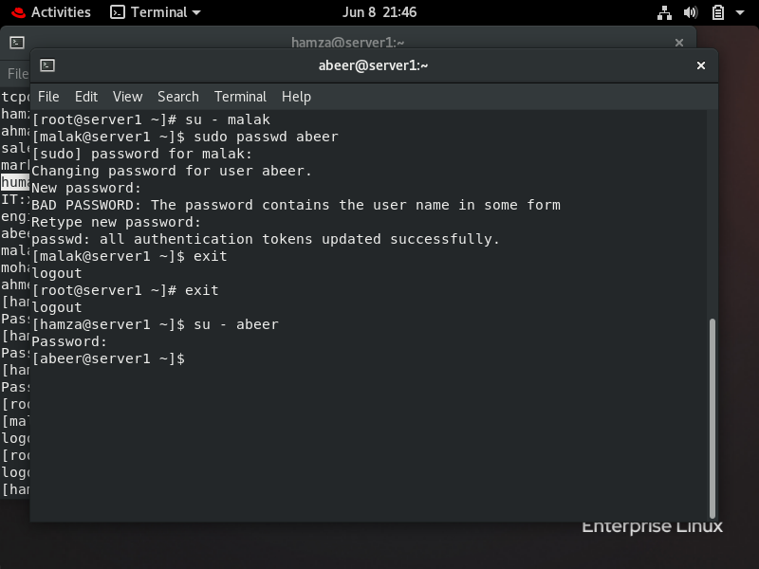

## Define the process using the most memory resources on the server

To determine the process using the most memory resources, I used top command with option (-n 5) to show first five iterations information about the process (PID, memory, CPU and others). Also, when I ran the top command, I pressed “M” to change the display to sort by the amount of memory as shown in the two figures below.

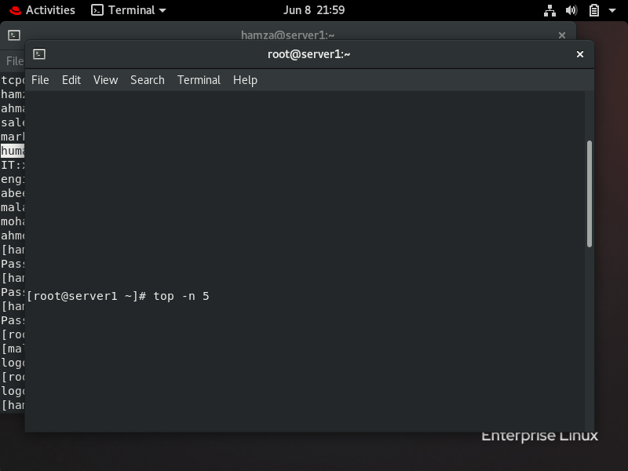

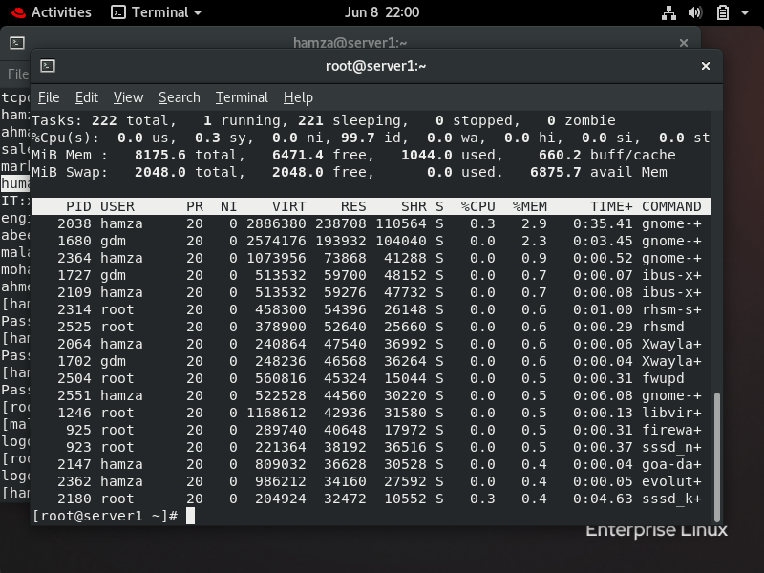

As shown in the figure above, the process with the highest memory in the server was with the PID “2038”.

After I identified the PID process, I terminated it using kill command as shown in the figure below. In default the kill command come with -SEGTERM- which means terminated that’s why I didn’t use any option with kill command.

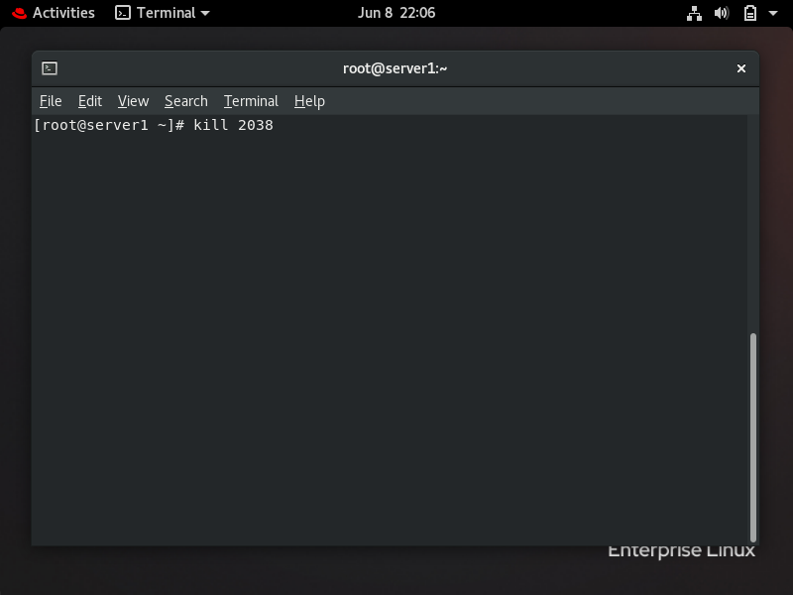

## Depending on vim, create four child process: file 1, file 2, file 3, and file 4, working in the background, after that, Kill the child process of file 3.

I Opened two terminals in the system, one for creating the files by using vim in the background by using symbol (&) as shown in the figure below:

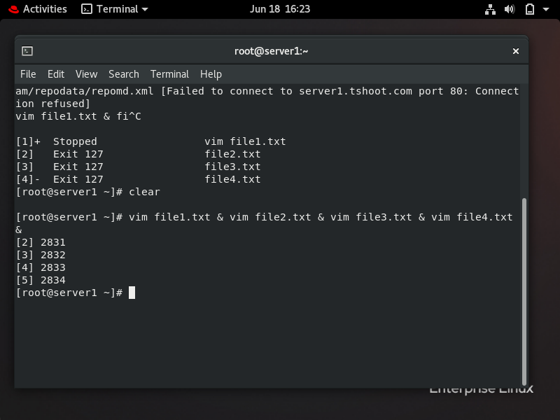

After that, from the second terminal, I used “pidof” command to get the PID of the process (file3.txt). After I got the PID of file3.txt, I killed it by using “kill” command as shown in the figure below.

## search for files with a size of more than 30 kilobytes in system

I searched for file with a size of more than 30 KB in the system using find command with these options :

/ -> means root , -type f -> means files , -size +30k -> size more than 30 KB.

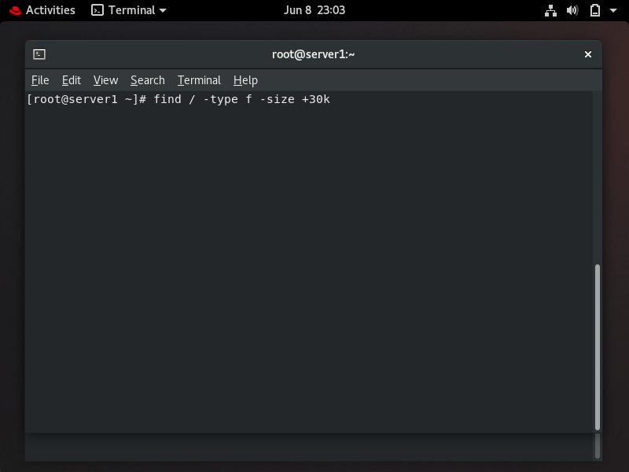

The output showed me there are a lot of file with size more than 30k , here is some of the files:

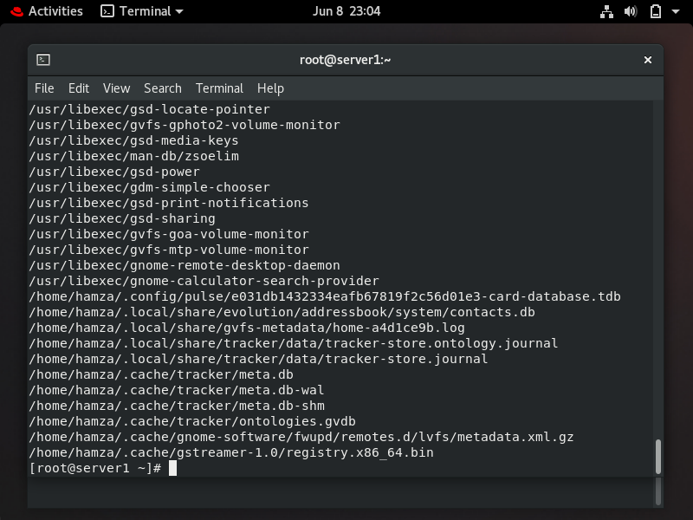

## Windows power shell

In Windows, I created multiple directories by using this command “New-Item -ItemType Directory -Path C:\name” as shown in the figure below.

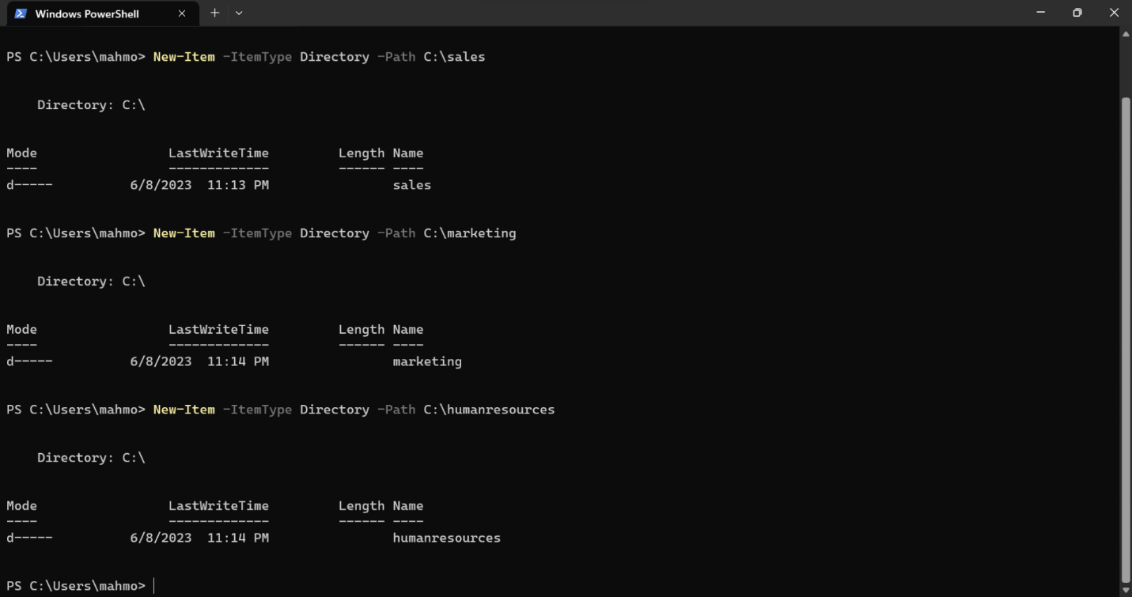

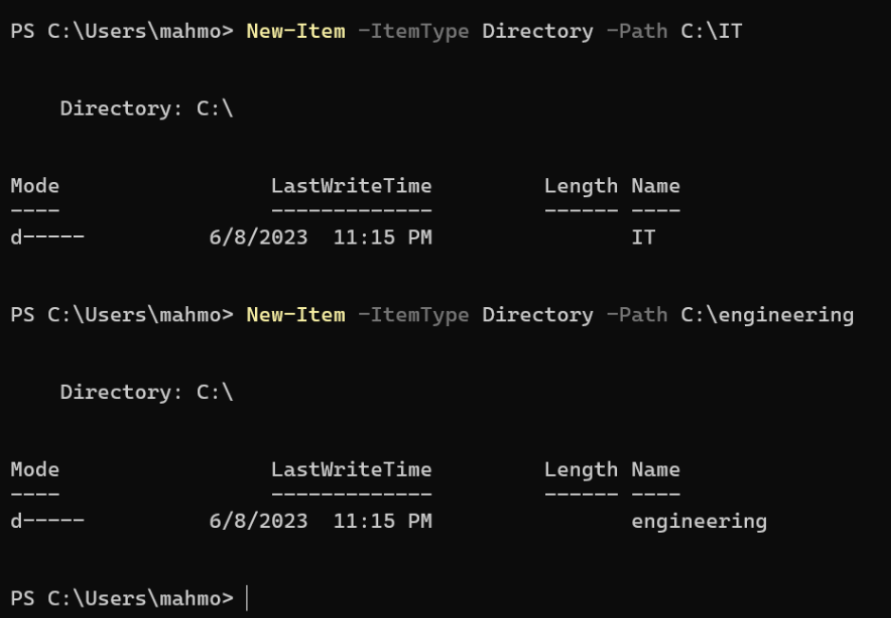

Then, I created files inside the sales directory by using this command “New-Item -ItemType File -Path C:\sales\test1,2,3.txt” as shown in the figure below.

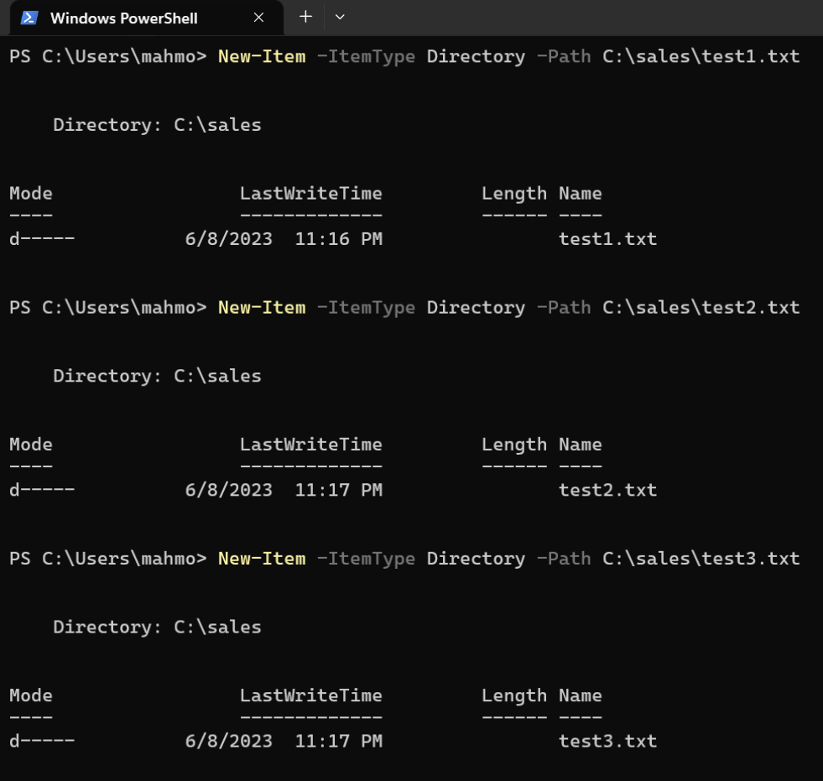

Also, from this command “Copy-Item -Path C:\sales\test1,2,3.txt -Destination C:\IT”, I copied the files from sales to IT directory.

I got the date by using this command “Get-date” as shown in the figure below.

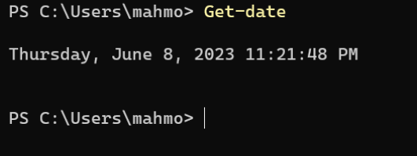

Finally, I created file in marketing directory using this command “New-Item -ItemType File -Path C: \marketing \text1.txt ”as shown in the figure below.

